Lake Hopatcong Elks Lodge #782
201 Howard Blvd., Mt. Arlington, NJ 07856 * (973) 398-0440 * Tax ID# 22-1664827
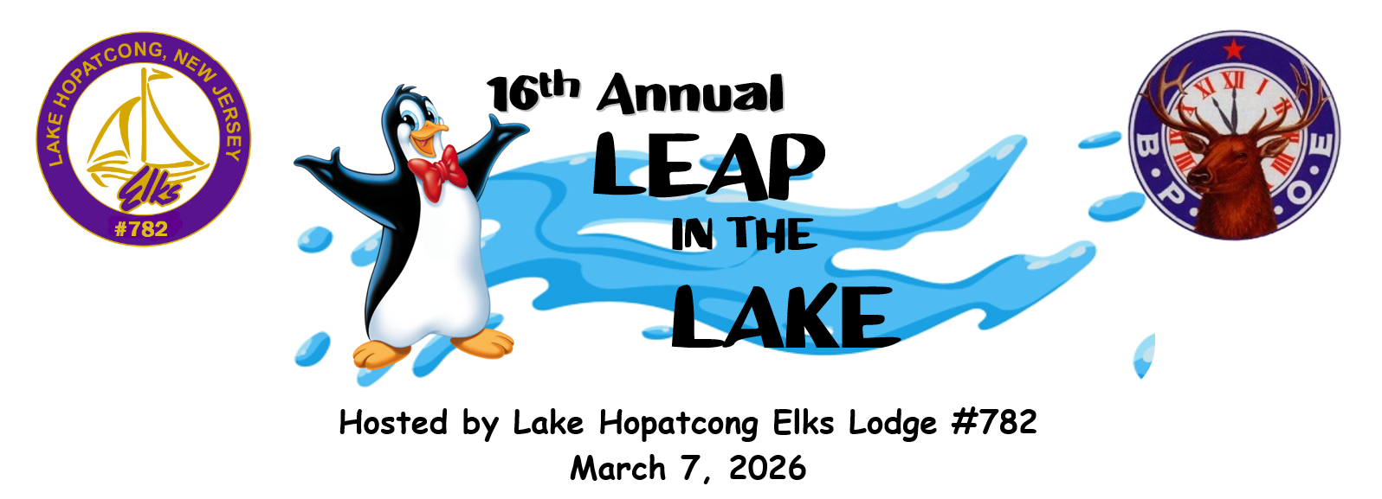

16th Annual Leap in the Lake for One Million Smiles

Dear Local Business:

Lake Hopatcong Elks is proud to announce our 16^{h} Annual "Leap in the Lake" will take place at Hopatcong State Park on March 1, 2026. Please consider making a donation towards this heart-warming and incredible event which raises funds for area special needs children and the youth in our community. The participation in this community event increases in size each year.
All sponsors are advertised on our website and Facebook page, as well as on the back of the sweatshirts that are given out to the more than 400 participants who brave the icy cold waters of Lake Hopatcong to raise money for these special children. Please visit our website, www.lakehopatcongelks.com to view the sponsors from last year, and visit us on Facebook at Lake Hopatcong Elks #782 - Leap in the Lake for our Special Kids to see the sponsors and photos of the event. In addition, this event is covered by many local newspapers and publications, including The Daily Record, Star Ledger, NJ.com, Lake Hopatcong News, Hopatcong Patch, Jefferson Patch and Our Town.
To be a sponsor of this event, please fill out the attached form and return it with your donation by February 23rd, 2026. In addition, in order for us to include your business logo on the event merchandise and website, please include a business card with your form or email your company logo to bpoe782@optonline.net.
Thank you for your support and for choosing to make a difference in the lives of our special children and youth in our community.
Fraternally yours,

Walter Wurster
Exalted Ruler
Lake Hopatcong Elks #782

PLATINUM SPONSOR $500.00
Includes the following:
- Listed as Premier Sponsor on event-shirt
- Platinum sponsor banner with your Art Work (company to supply camera ready artwork)
- Name recognition in advertising material i.e.: Website, Flyers, Emails, and Press Releases.
- Two (2) complimentary tickets to the Pre-Leap Cocktail Party
- Two (2) complimentary tickets to the After Leap Party
- Two (2) Leap in the Lake shirts

GOLD SPONSOR $100.00
Includes the following:
- Listed as Gold sponsor on event-shirt
- Gold sponsor group banner with your Art Work (company to supply camera ready artwork)
- Name recognition in advertising material i.e.: Website, Flyers, Emails, and Press Releases.
- One (1) Leap in the Lake shirt

NAME:________________________________________________________________________

ADDRESS_______________________________________________________________________

CITY______________________________________STATE_________ZIP___________________

PHONE: _______________________ EMAIL: ____________________________________________ SHIRT SIZE ________

***DEADLINE FEBRUARY 23rd, 2026***
SPONSORSHIP TYPE: PLATINUM GOLD

